Name: Yousef Alaa Elden Shaker Turky

Track: Data engineering

Location: Ismailia

Project: EDA of terrorism dataset using python

# Preprocessing

**Selecting relevant columns**: Only the important columns related to the analysis were retained in the Data Frame.

**Handling missing values**: Missing values in the 'nkilled', 'nwounded', 'provstate', 'city', and 'motive' using median for numeric coulmns and The word ‘Unknown’ for non-numeric values.

**Checking for null values**: The Data Frame was checked for null values, and it was found that there were no null values remaining after cleaning, filtering and replace values.

# Descriptive statistics

Countries with most attacks Regions with most attacks

* Number - Cities with most attacks

of attacks per year

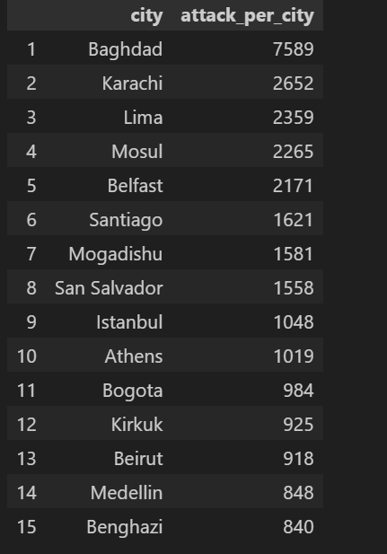

* Kills per year - Wounds per year

* Groups with most attacks

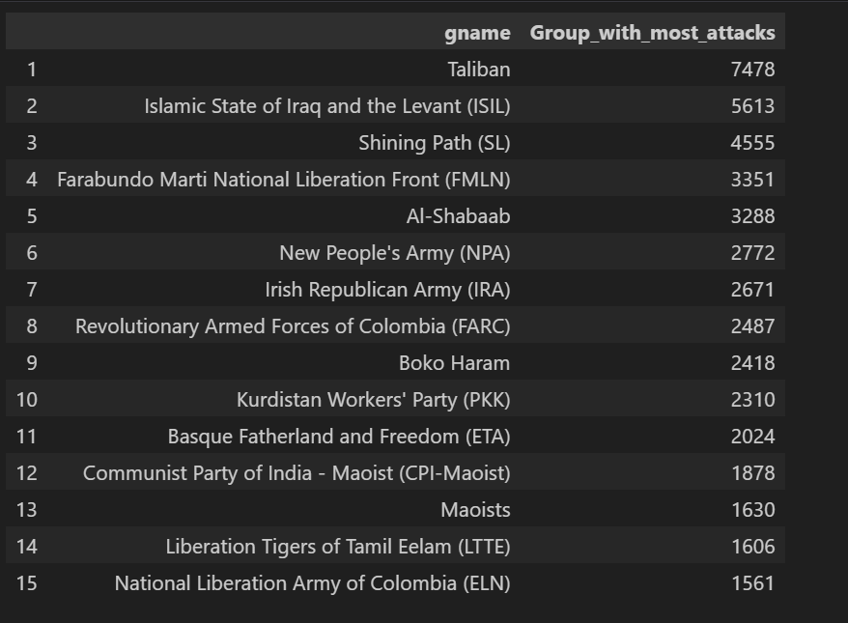

* 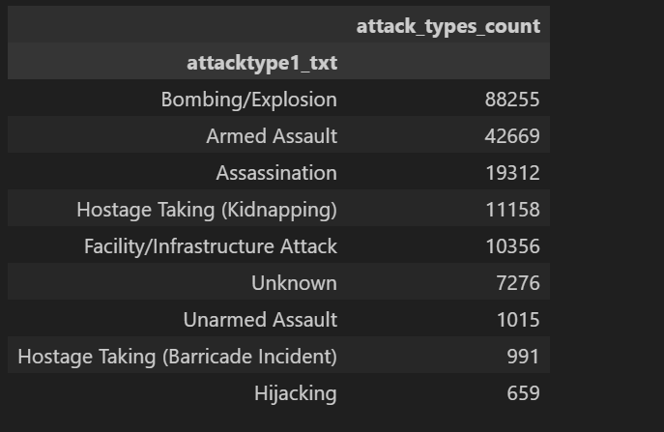Most common attack types
* Most type of people affected from terrorists attacks

# Data Visualization

Terrorism Attacks over the year

Attack per region

Attack per country top 30 countries

Correlation between numeric columns

The relationship between the number of casualties and the type of attack

* Insights derived from data:
  + Most attacks happen in the middle east region
  + Most attacks happen in Iraq country
  + Most attacks happen in Baghdad city
  + Group with most terrorist attack is Taliban
  + The most affected group from terrorism is Private Citizens & Property
  + Most used weapon is Explosives
  + Most common attack Types is Bombing/Explosion

Performance comparison between Dask and pandas :

* Reading data
  + Using Dask: 0.11 sec
  + Using pandas: 2.68 sec
* making group by region to get the sum
  + using Dask: 1.35 sec
  + Using Pandas: 4.57 sec